**Final Year B.Tech. (CSE) – II [ 2022-23 ]**

**Cryptograpy and Network Security Lab**

**PRN: 2019BTECS00015**

**Full name: Shraddha Sanjay Kharat**

**Batch: B1**

**Assignment No. 13**

**Title:** Digital Certificate Generation

**Aim:** To Demonstrate Digital Certificate Generation using keytool

**Theory:**

Digital certificate is issued by a trusted third party which proves sender’s identity to the receiver and receiver’s identity to the sender. A digital certificate is a certificate issued by a Certificate Authority (CA) to verify the identity of the certificate holder. The CA issues an encrypted digital certificate containing the applicant’s public key and a variety of other identification information. Digital certificate is used to attach public key with a particular individual or an entity.

Digital certificate contains:-

Name of certificate holder, Serial number which is used to uniquely identify a certificate, the individual or the entity identified by the certificate, Expiration dates, Copy of certificate holder’s public key, Digital Signature of the certificate issuing authority.

**Screenshots:**

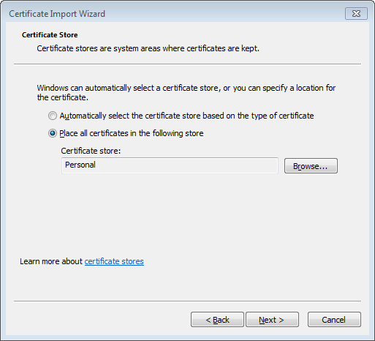

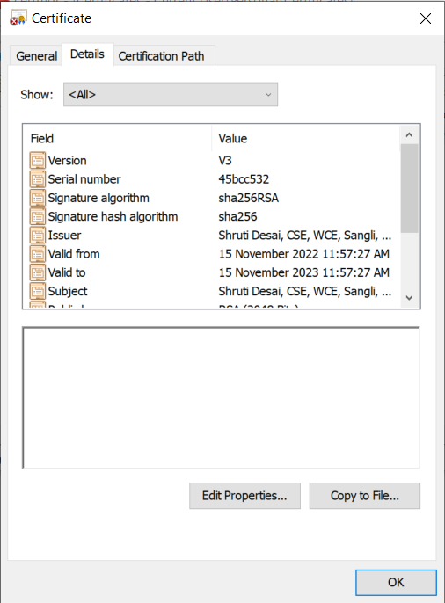

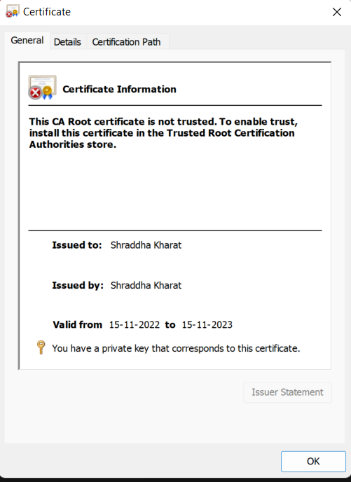

**Conclusion:**

Digital certificate is a file that ensures holder’s identity and provides security. It is generated by CA (Certifying Authority) that involves four steps: Key Generation, Registration, Verification and Creation.